PROCEDURES FOR ENROLMENT

Rationale (Legislative Context):

The government school system in New South Wales exists to provide high quality education for all students. The Education Reform Act 1990 outlines the objects of education and the legal requirements for compulsory schooling. In brief, the legislation requires students between the ages of six and fifteen to be enrolled at a government or registered non-government school, and to attend school on each day that instruction is provided or to be registered for home-schooling. It is the duty of the parent or carer of the student to ensure that these obligations are fulfilled.
Children are entitled to be enrolled at a government school that is designated for the intake area within which the child’s home is situated and that the child is eligible to attend. Parents may also seek to enrol their child in the school of their choice.
No person will be discriminated against in enrolment on the grounds of their sex, age, race, religion, ethnicity, disability, sexual preference or marital status.

Guidelines:

- A student is considered to be enrolled when he or she is placed on the admission register of a school.
- A student should be enrolled in one school only at any given time.
- Children are entitled to be enrolled at the government school that is designated for the intake area within which the child’s home is situated and that the child is eligible to attend.
- Parents may seek to enrol their child in the school of their choice.
- School local areas are determined by the Department of School Education through a process involving consultation between the Properties Directorate and the Team Director.
- Schools are required to set an enrolment number to cater for anticipated local demand and to seek to ensure that every eligible local child has a place at his or her local school if he or she chooses to attend it.
- Schools are required to have a written policy that states the grounds on which non-local enrolments will be accepted.
- The primary criteria for acceptance of non-local enrolments will include the availability of appropriate staff and permanent classroom accommodation.
- The decision on where to enrol a student, and with what level of support, will depend on a number of factors, including a student’s educational needs, the expressed desires of parents and caregivers, the capacity of the system to provide the level of support services required generally and at a particular location and the availability of support services at alternative locations.
- The requirements of Occupational Work and Safety will be considered before any student is enrolled at the school.

Enrolment of Students in NSW Government Schools: Ref # PD/2002/0006/V01
Enrolment Ceiling:
Each school will establish an enrolment ceiling, based on available permanent accommodation

Recommended Class Sizes
- Kindergarten 20 Student
- Year 1 22 Students
- Year 2 24 Students
- Year 3-6 30 Students

Enrolment Buffer:
As no additional accommodation (permanent or demountable) will be provided to cater for increased enrolments resulting from non-local placements a buffer of 3 students per grade has been determined which will allow the school to meet the particular needs of the grade.

This buffer is to cater for unexpected local students arriving throughout the year and is based on historical data, enrolment fluctuations and on the number of families moving into or out of the area.

Local Enrolment (in accordance with the policies of NSW DEC):
Local students must be enrolled at any time during the year, regardless of class sizes. All local enrolments must apply to enrol at the office. Proof must be shown of a place of residence and the previous school contacted for relevant student information. The enrolment procedure does not continue until the previous school has been contacted and a transfer document has been requested.

Parents/caregivers must provide one form of documentary evidence of their place of residence within the school boundary. This evidence can be in the form of

- Rent or lease agreement
- Mortgage papers
- Utilities account
Note: a driver’s licence is not considered to be evidence of residential address

Boundary (Local Area Warilla North):
The local boundary is indicated on the map attached. A copy is also available at the school office.
For streets included in this area please go to: https://education.nsw.gov.au/school-finder

Non Local Enrolment Applications:
Parents and carers, who seek non local enrolment on behalf of their children, will be informed of the following procedures which detail the grounds on which non local enrolments will be accepted. Priority for enrolment will be given to students entering Kindergarten. Places may also be available in Years 1-6.

If demand exceeds availability, the school will establish a placement panel to consider and make recommendations on all non-local enrolment applications. The composition of the panel is to be determined locally but must include at least one staff member, the Assistant Principal, and one school community member nominated by the school’s parent organisation. The panel will be chaired by the Assistant Principal who will have a casting vote. The decisions made by the placement panel must be made within the context of the agreed enrolment ceiling.

In assessing the application of the criteria to individual cases, the panel will consider only those matters presented on the application form and not oral or other submissions. The decisions made by the placement must be made within the context of the agreed enrolment ceiling and buffer retained for local students arriving later in the year. The placement panel will record all decisions.

Enrolment of Students in NSW Government Schools: Ref # PD/2002/0006/V01
Criteria for Non Local Enrolment Applications:
The primary criteria for acceptance of non-local enrolments will include the availability of appropriate staff and permanent classroom accommodation.

Other criteria (not listed in a priority order)
- proximity and access to the school
- siblings already enrolled at the school
- access to single-sex education
- medical reasons
- safety and supervision of the student before and after school
- availability of subjects or combinations of subjects
- special interests and abilities
- compassionate circumstances
- structure and organisation of the school.

Parents will be informed in writing regarding the success of their application.

Waiting Lists:
Waiting lists may be established for non-local students. Parents will be advised in writing if their child is to be placed on a waiting list. The size of the waiting list will reflect realistic expectations of potential vacancies.

Appeals:
Where a parent wishes to appeal against the decision of the placement panel, the appeal should be made in writing to the principal. Where required, the principal should provide or arrange assistance, such as interpreter, to enable the appeal to be set out in writing. The principal will seek to resolve the matter, however, provided the policy has been adhered to, cannot overturn the final decision of the panel.

If the matter is not resolved at the local level, the Director will consider the appeal and make a determination. The Director will consult relevant principals and school communities as necessary. The purpose of the appeal is to determine whether the stated criteria have been applied fairly.

Kindergarten Enrolment:
Children may enrol in Kindergarten at the beginning of the school year if they turn five years of age on or before 31 July in that year. Documentation providing proof of age, such as a birth certificate or passport, is required on enrolment.

The Principal is to ensure that enrolments proceed as quickly as possible in a manner which is in the best interests of the incoming children. Applications for enrolment will be accepted from the commencement of Term 2 of the year prior to enrolment.

Whilst it is the intention that children be enrolled at the beginning of the year, parents who choose to enrol eligible children after the beginning of the school year may do so, up to the end of Term 2.

The Public Health (Amendment) Act 1992 requires parents to provide documented evidence of a child’s immunisation status on enrolment in schools. Parents have the right of not having their children immunised. However, in the event of an outbreak of a vaccine preventable disease, unimmunised children will be required to remain at home for the duration of the outbreak.

Enrolment of Students in NSW Government Schools: Ref # PD/2002/0006/V01
Short Term and Part Term Attendance of students:
A student should be enrolled in one school only at any given time. Where the period is no more than one term, or in the case of a student involved in a special placement of no more than 2.5 days per week, the student should not be enrolled, but regarded as being on a short term attendance. The home school should maintain the student’s name on an attendance register, with a note to the effect that the student is attending another school.

The school the student attends for a short term (the host school), must keep a record of the student’s attendance and notify the home school at the end of the stay or, in the case of part-time attendance, at the end of each term.

Refusal of Enrolment:
Principals may refuse enrolment of a student on the grounds of previously documented violent behaviour if there is evidence that the student has not learned the appropriate skills to manage this behaviour.

Enrolment Data:
Complete and accurate enrolment information, supported by adequate enrolment and attendance documentation to meet accountability and audit requirement, is maintained at the school.

- to comply with legal requirements
- for school administrative purposes
- for resourcing, accountability and reporting requirements.

The procedures document was developed and implemented in 2019 and will be reviewed in 2021.

For more detailed information regarding enrolment in a government school please visit:

https://education.nsw.gov.au/public-schools/going-to-a-public-school

Enrolment of Students in NSW Government Schools: Ref # PD/2002/0006/V01
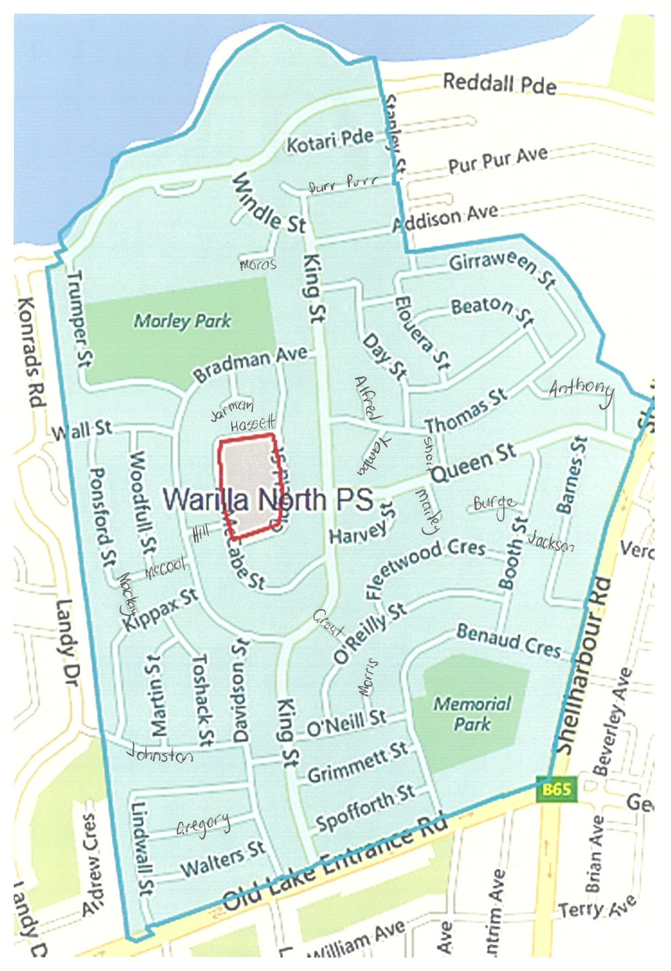
Boundary Map (Local Area Warilla North)

