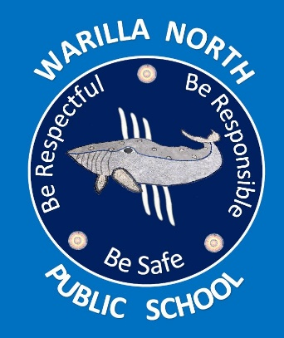
WARILLA NORTH PUBLIC SCHOOL
Uniform Order Form
Please return to office

STUDENT NAME: _________________________

ITEM | SIZE RANGE | PRICE | SIZE | QTY | TOTAL
Polo Shirt  with emblem | 4, 6, 8, 10, 12, 14, 16 | $35
Cargo Shorts | 4, 6, 8, 10, 12, 14, 16 | $20
Girls Skort | 4, 6, 8, 10, 12, 14, 16 | $25
Sport Shirt | 4, 6, 8, 10, 12, 14, 16 | $35
Sport Shorts | 4, 6, 8, 10, 12, 14, 16 | $12
Jacket | 4, 6, 8, 10, 12, 14, 16 | $60
Hat | XS, S, M | $6
Dress | 5,6,8,10,12,14 | $40
Double Knee Tracksuit Pants | 2,4,6,8,10,12,14,S | $25
Girls Pants | 4,6,8,10,12,14,S | $25
Cap | 54cm, 57cm | $20
Total Cost

