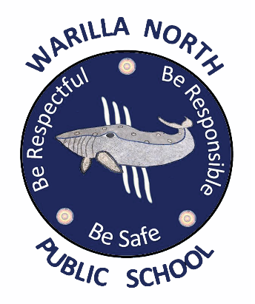
WARILLA NORTH PUBLIC SCHOOL
Uniform Order Form
Please return to office

STUDENT NAME: _________________________

ITEM | SIZE RANGE | PRICE | SIZE | QTY | TOTAL
Polo Shirt | 4, 6, 8, 10, 12, 14, 16 | $37
Cargo Shorts | 4, 6, 8, 10, 12, 14, 16 | $20
Girls Skort | 4, 6, 8, 10, 12, 14, 16 | $25
Sport Shirt | 4, 6, 8, 10, 12, 14, 16 | $37
Sport Shorts | 4, 6, 8, 10, 12, 14, 16, M, L | $12
School Jacket | 4, 6, 8, 10, 12, 14, 16 | $65
Hat | XS, S, M, L | $6
Dress | 5, 6, 8, 10, 12, 14 | $40
Double Knee Tracksuit Pants | 2, 4, 6, 8, 10, 12, 14, S | $20
Girls Pants | 4, 6, 8, 10, 12, 14, S | $14
Fleecy Black Jacket | 4, 6, 8, 10, 12, 14, 16, M, L, XL | $30
Girls Jazz Pants | 4, 6, 8, 10, 12, 14, 16, 18 | $14
Tracksuit Pants | 4, 6, 8, 10, 12, 14, 16 | $20
Cap | 54cm, 57cm | $20
Total Cost

