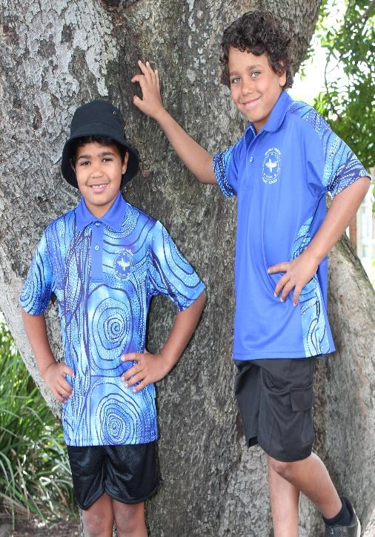
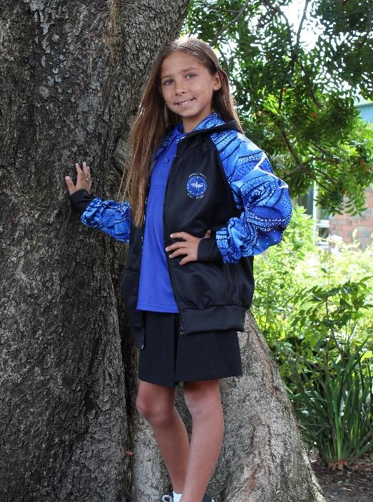
Warilla North Public School 2022
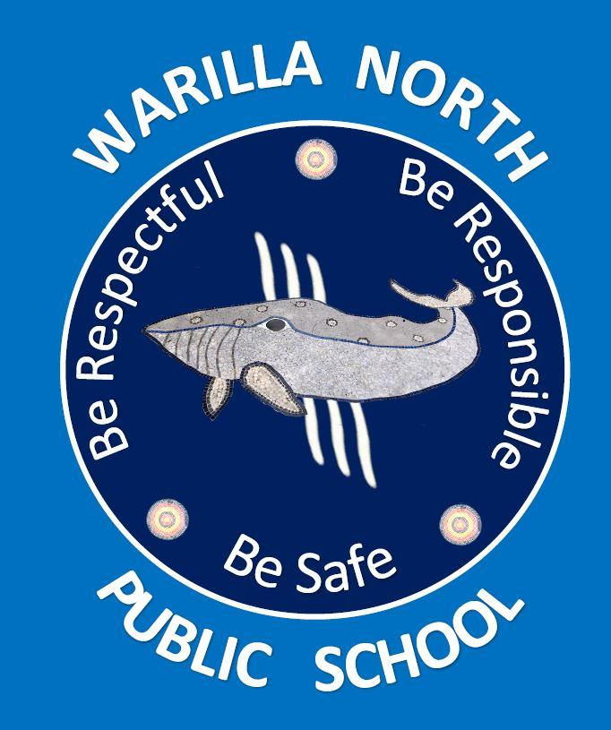
SCHOOL UNIFORM POLICY
The Department of Education and Communities School Uniform Policy requires schools to review and document school uniform or dress code requirements in consultation with their communities and to develop strategies for the wearing of school uniforms. School uniforms should reflect school community standards and be consistent with occupational health and safety, anti-discrimination and equal opportunity legislation.
School uniforms in NSW Public Schools Guidelines (2004), https://education.nsw.gov.au/policy-library/associated-documents/schuniforms.pdf have been developed to support the implementation of the policy.
Benefits of School Uniform (p.4 Guidelines)
The wearing of school uniforms by students will assist school communities in:
- Defining an identity for the school within its community
- Developing students’ sense of belonging to the school community
- Providing an opportunity to build school spirit
- Enhancing the health and safety of students when involved in school activities
- Promoting a sense of inclusiveness, non-discrimination and equal opportunity
- Reinforcing the perception of the school as an ordered and safe environment
- Increasing the personal safety of students and staff by allowing easier recognition of visitors and potential intruders in the school
- Promoting positive community perceptions of public education
- Making school clothing more affordable for families by eliminating the risk of peer pressure to wear certain clothing

1 School Uniform Policy Review Date : March 2023
Warilla North Public School 2022

Principles (p.5 Guidelines)
A school uniform should:
- Cater for all students in the school community in a manner sensitive to gender and local cultural and social issues including cultural and religious diversity
- Meet requirements of occupational health and safety, anti-discrimination and equal opportunity legislation
- Promote the health and safety of students by identifying items necessary for particular activities e.g. items for sun protection
- Include items that are affordable, comfortable, made from easy-care and easy wear fabrics, appropriate for activity and suitable for all body shapes
- Provide girls and boys with equal access to the full range of school activities
- Include strategies for promoting the wearing of the school uniform
- Be reviewed regularly and amended as needed

Legislative Requirements (p.6 Guidelines)
Under the Occupational Health and Safety Act 2000 (OH&S Act), the Department of Education must ensure that students are not exposed to risks to their health or safety while they are on Departmental premises.
School uniform requirements must take into account these requirements. Anti-discrimination legislation contains two definitions of discrimination: direct and indirect discrimination. Both are against the law. Direct discrimination means treatment that is obviously unfair or unequal. Indirect discrimination refers to a requirement or rule that is the same for everyone but has an unequal impact and is unreasonable in particular circumstances.
The implications of equal opportunity legislation are such that uniforms must enable both sexes to participate actively and safely in school life. In promoting the wearing of school uniform, principals must be sensitive to economic, personal, social and cultural factors affecting individual students and their families.

2 School Uniform Policy Review Date : March 2023
Warilla North Public School 2022

Strategies to Recognise and Promote the Wearing of School Uniform (p.9 Guidelines)

Positive approaches to recognise and encourage students who wear school uniform may include:
- Formal recognition of groups of students at assemblies or by other means
- Reference to the uniform as part of recognition and promotion of the spirit of the school
- Letters of acknowledgement to parents and students from staff
- Positive comments in individual school reports about students who support the school ethos, have pride in their school and represent it well
- Reminders to students that standards of dress have been agreed upon for the health and safety of students
- Involvement of student representative councils in developing, discussing and promoting school uniforms

Note 1: Despite the above strategies some students may not wear school uniform. Under certain circumstances, occupational health and safety legislation provides the basis for principals to require students to wear school uniform. Where the health and safety of the student or of other students would otherwise be compromised, students may be excluded from certain educational activities. Such action may also be required if a student’s clothing compromises agreed upon school community standards articulated in the school uniform requirements and might be considered damaging to the image of the school in the larger community context. With the above exceptions, no student will have their access to learning reduced because they are out of uniform. This includes their continued participation in essential curriculum activities.

Note 2: Strategies that may assist for individual students resisting the wearing of school uniform include:
- Speaking to the student to encourage wearing of the school uniform
- Providing a verbal warning to the student
- Providing advice to the parents via a letter from the classroom teacher. After three letters advising of incorrect uniform, a member of the executive staff may contact parents/carers via phone call to discuss issues/ situation.
- Negotiating an appropriate course of action with the students and parents.

3 School Uniform Policy Review Date : March 2023

Warilla North Public School 2022
At Warilla North Public School the School Dress Code is as follows and will be strictly adhered to:
Summer :
- Plain black shorts (no logos / colours). Minimum mid-thigh length required
- black skort – same as school issue. Minimum mid-thigh length required
- ( bike pants / exercise pants / jeans / elastine active sport skorts are NOT permitted)
- school royal blue with side pattern polo
- white or black socks
- all black shoes with black soles and black laces
- blue checkered school dress. Minimum mid-thigh length required
Winter:
- long, plain black slacks (no bike/exercise pants)
- plain black track pants
- school royal blue with side pattern polo
- blue checkered school dress with black stockings
- school jacket
- plain black jumper/sloppy-joe/zippered jacket (no logos/colours)
- black / white socks
- all black shoes with black soles and black laces

Sports Uniform :
- black school sport shorts. Minimum mid-thigh length required
- school sports polo shirt
- joggers/sandshoes
Accessories:
- Black school bucket hat / school cap/ or plain black cap/hat (no logos or colour) to be worn in playground
- No make-up
- Jewellery limited to small stud/sleeper earrings and small stud for other piercings, watch, signet ring and Medi-alerts
- Hair accessories to be small, basic items in school colours of royal blue or black.
- NO coloured hair extensions or coloured dyed hair
- NO false nails

4 School Uniform Policy Review Date : March 2023

