This is the final newsletter for Term 1. I hope that our fortnightly newsletter has helped to keep you up to date with everything that is happening in the school. Our facebook page and website are our other methods of communicating with our parent community.
Anzac Day School Assembly
Our school Anzac Day assembly will be held on Tuesday 4 April at 9:30am in the COLA area. A representative from Warilla RSL will be in attendance. Parents are very welcome to attend.
Easter Hat Parade
Our annual Easter Hat Parade will be held on Thursday 6 April. The parade will start at 12:45pm. All classes will parade under the COLA. Following this there will be a Sausage Sizzle. Sausage sandwiches will be $2 and drinks $2.50. All families are welcome to join in this annual event.
Easter Raffle
Thank you to all our families that have donated items and bought tickets in our easter Raffle. The raffle will be drawn at the conclusion of our Easter Hat Parade on Thursday. Good luck to everyone!
Staff Professional Learning
The staff development day on Monday 24 April will focus on Aboriginal Education. Staff will be participating in online learning and webinars, revisiting our local story and collaborating on our Aboriginal education Action Plan.
Back to School Vouchers
At this point in time we are unable to accept Back to School vouchers when paying for excursions. We continue to accept these for uniform sales.
Attendance
We want your child at school every day, even when it is raining! We understand this can be challenging but every day your child misses, their learning will be impacted.
If you experience challenges getting your child to school any day, even on a rainy day, (e.g. you don’t have a car), chat with your child’s teacher or phone the office so we can work with you to find some solutions. We are here to work in partnership with you.
Having a day off here and there can add up quicker than you may realise. If you are interested in finding out your child’s current attendance rate, ask your child’s teacher and they can let you know.

School Holidays
School finishes for the term on Thursday 6 April. The Staff Development Day is on Monday 24 April. Students return on Wednesday 26 April. I hope all of our families have a restful and enjoyable break.
Mrs Armer
Coming Events – April
Week 11
Tuesday 4 April | ANZAC Day service
Monday 24 April | Staff Development Day
Wednesday 26 April | Students return to school
Thursday 27 April | Cross Country

Canteen News
From Wednesday April 26 our school canteen will be operating 5 days a week for both lunch and recess.
There is a brand new menu that will commence at this time. Please check your child’s bag for this updated menu. We will also be publishing this on our Facebook page and website.
We are excited to be able to provide this service to our community and are looking forward to having lots of new and exciting items for sale and also celebrating special events with meal deals throughout the term.

Bike Safety Program
On Monday some students participated in a bike safety program organised by Aboriginal Bike Safety and delivered by Bike and Fitness. Students’ bikes were checked for safety and any repairs were carried out. The children cycled around a course and road rules were adhered to. Good, safe fun was had and the students received a new bike helmet. Thank you Bike and Fitness and the teachers who stayed back to supervise this worthwhile activity.
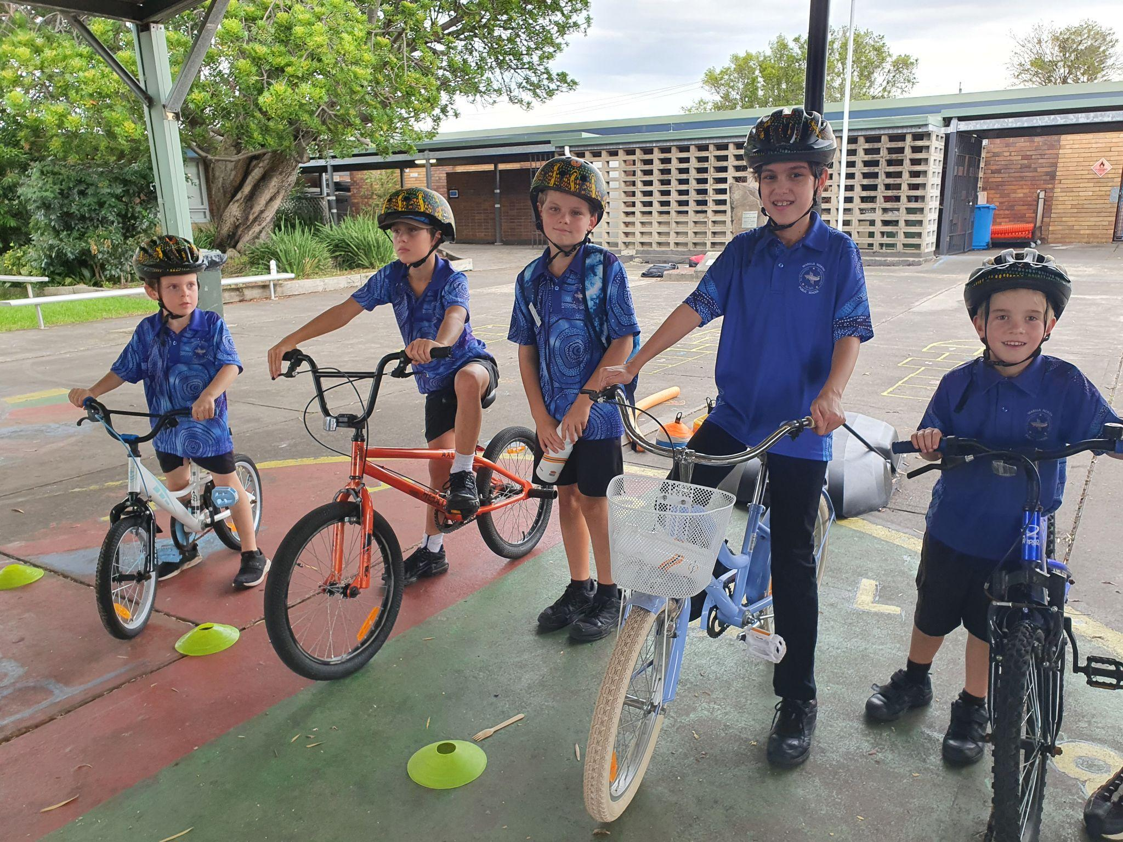
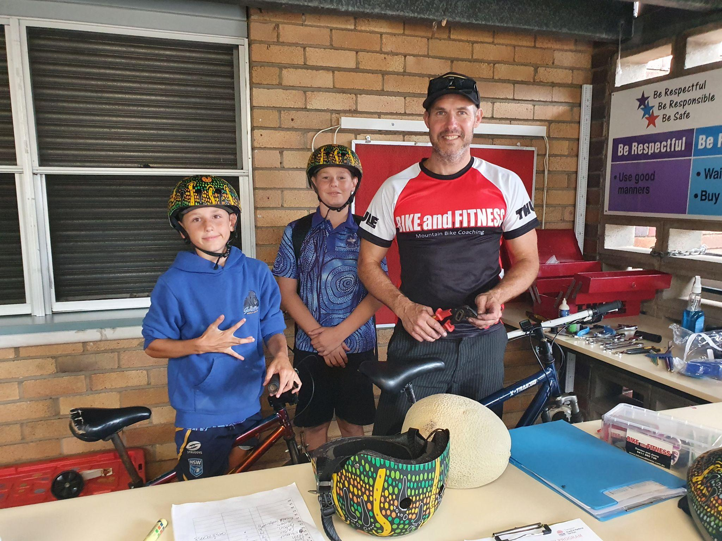
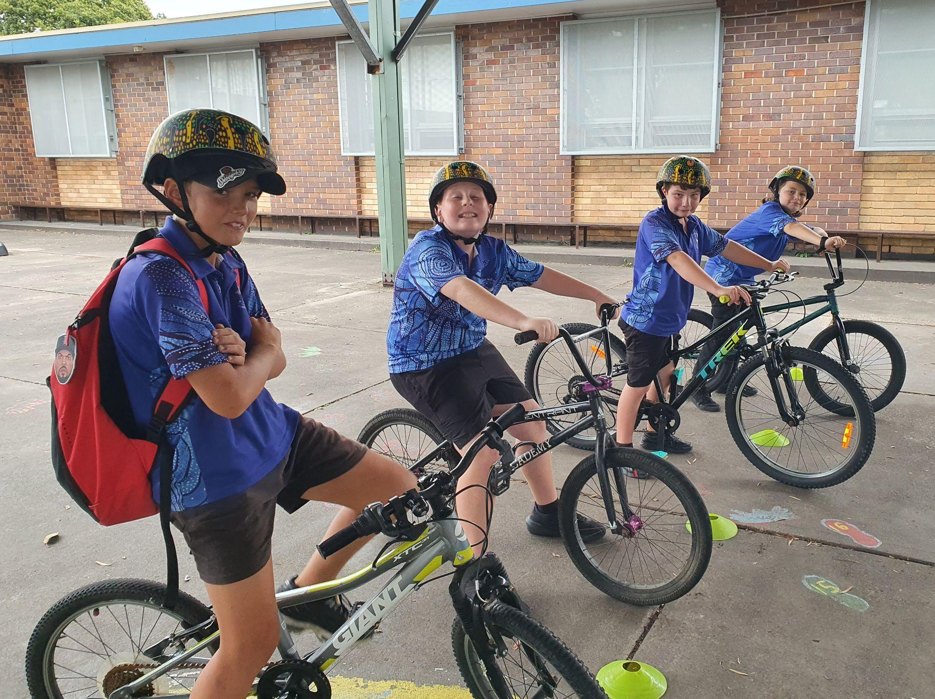

Library Stage1 and Stage 3

In the Library this term all the students have created some awesome artworks. Stage 1 have painted, coloured, cut and glued artworks inspired by some of the books they have been reading in class and in the library.

Stage 3 created a variety of landscape pictures including photographs. There seems to be some budding photographers in our senior students as some of the photos were stunning.

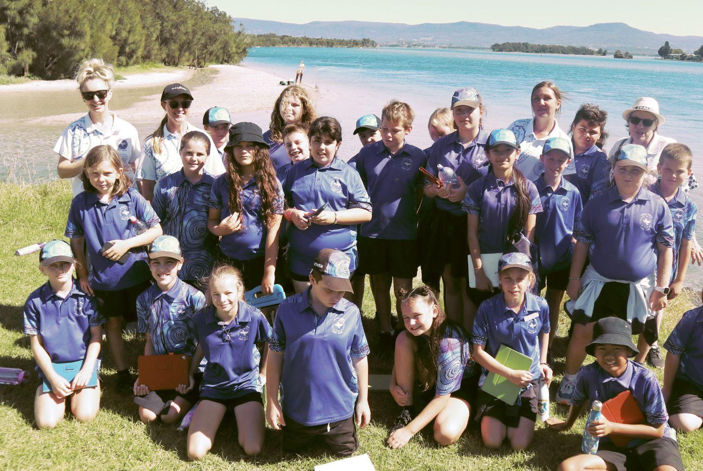
Stage 1

Students from 1/2 Gugara and 1/2 Gurunuba celebrated the end of Term 1 by going on an excursion to Shellharbour Library and Civic Centre.
Gugara
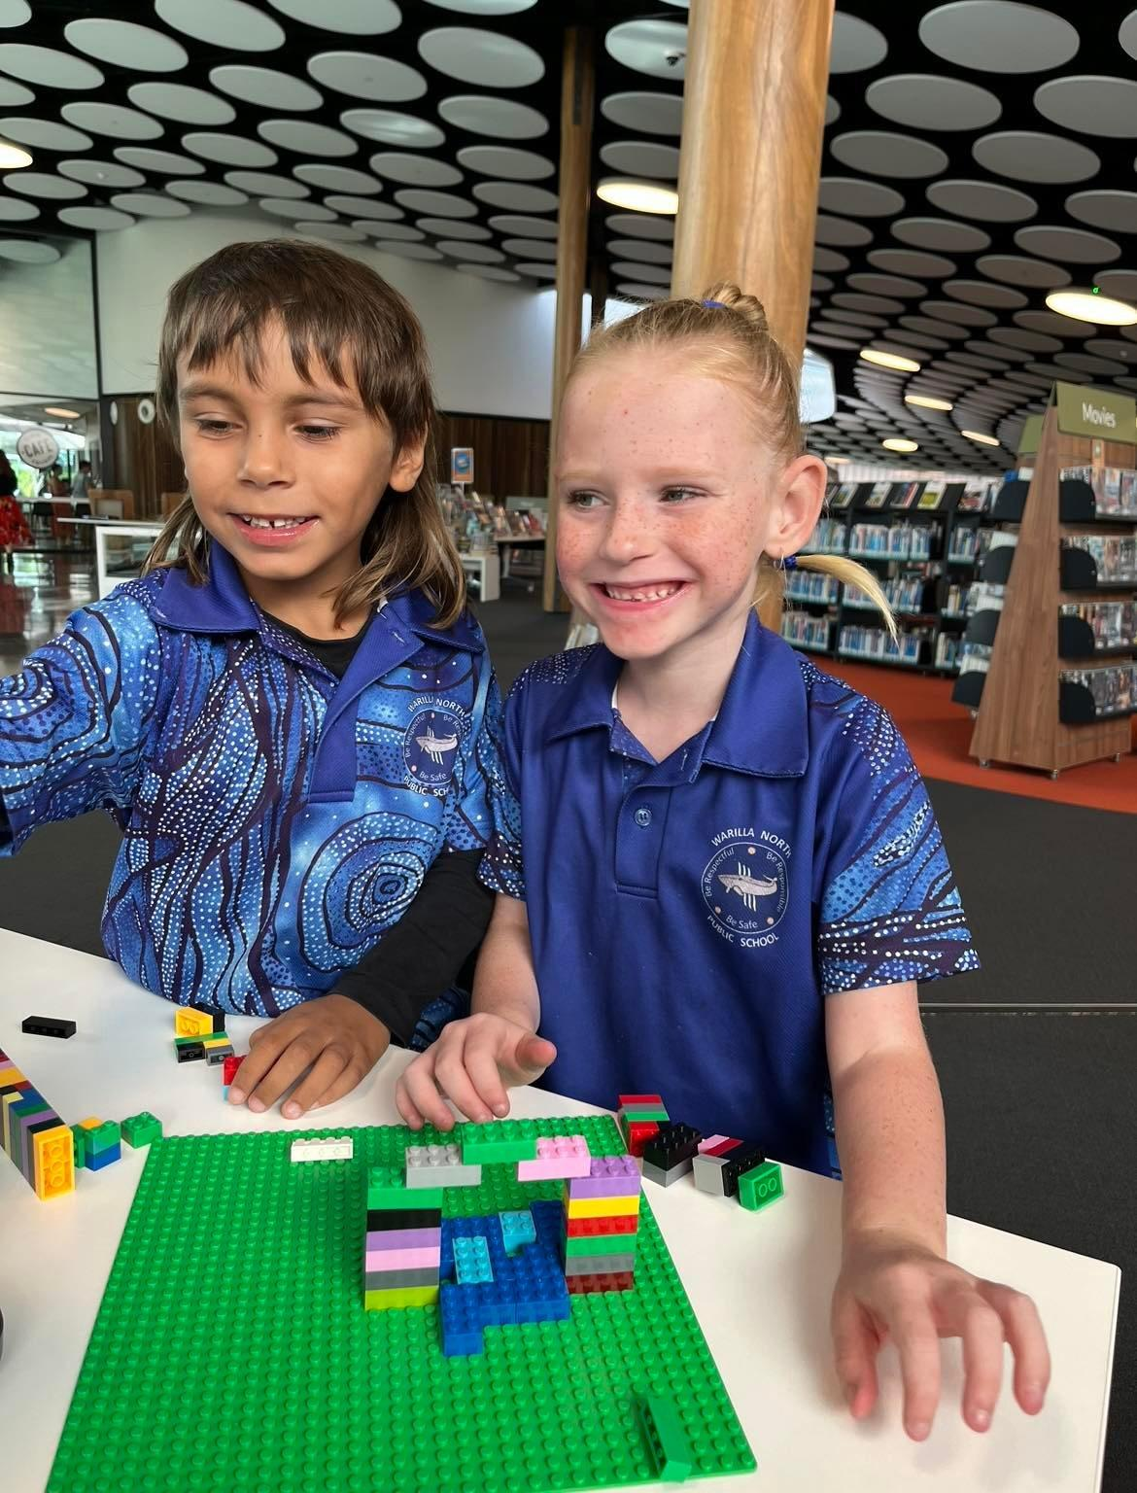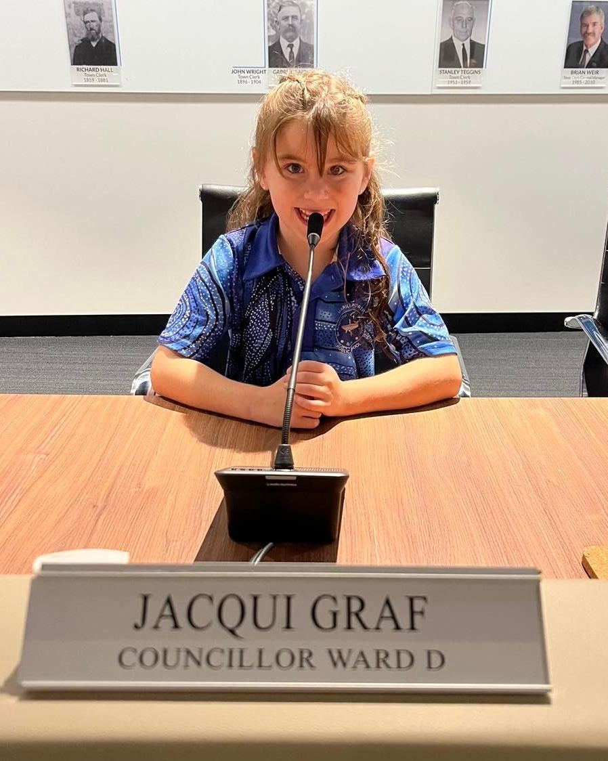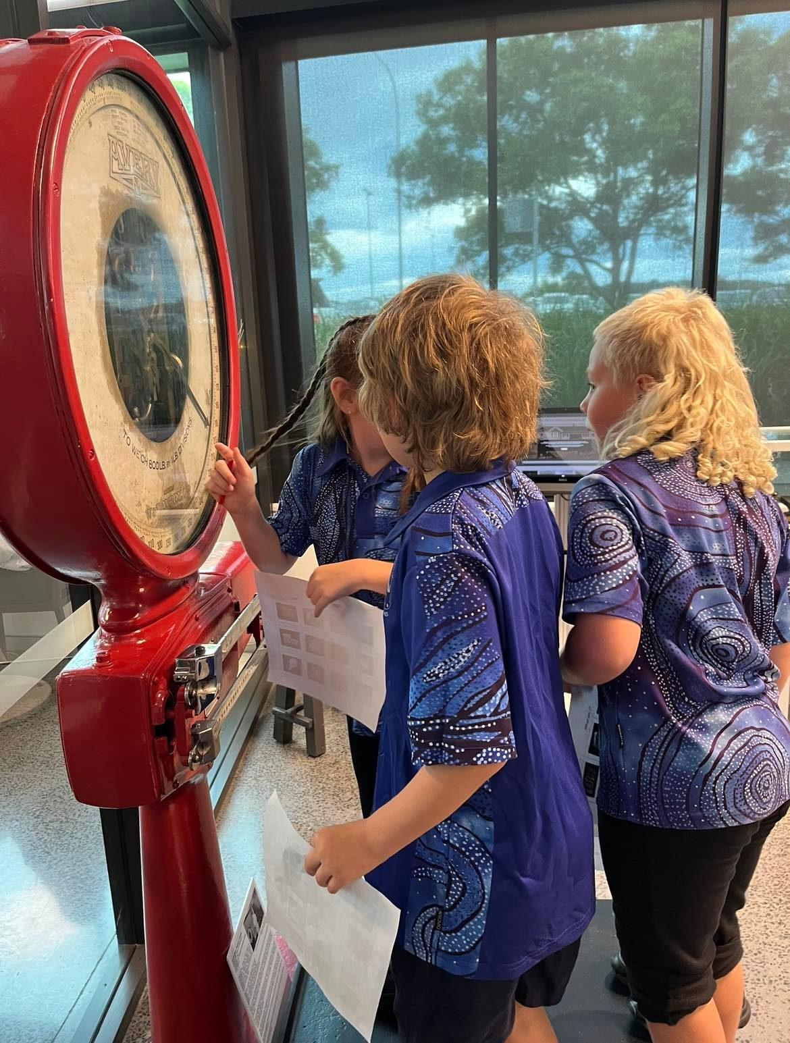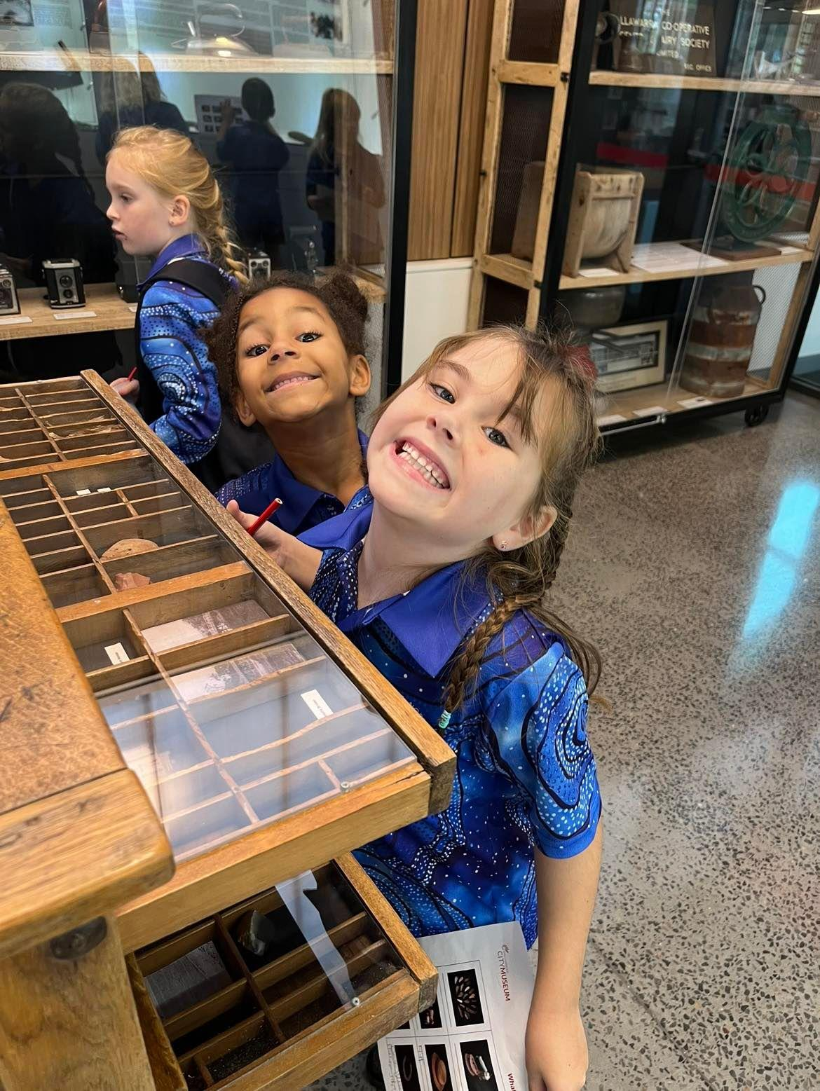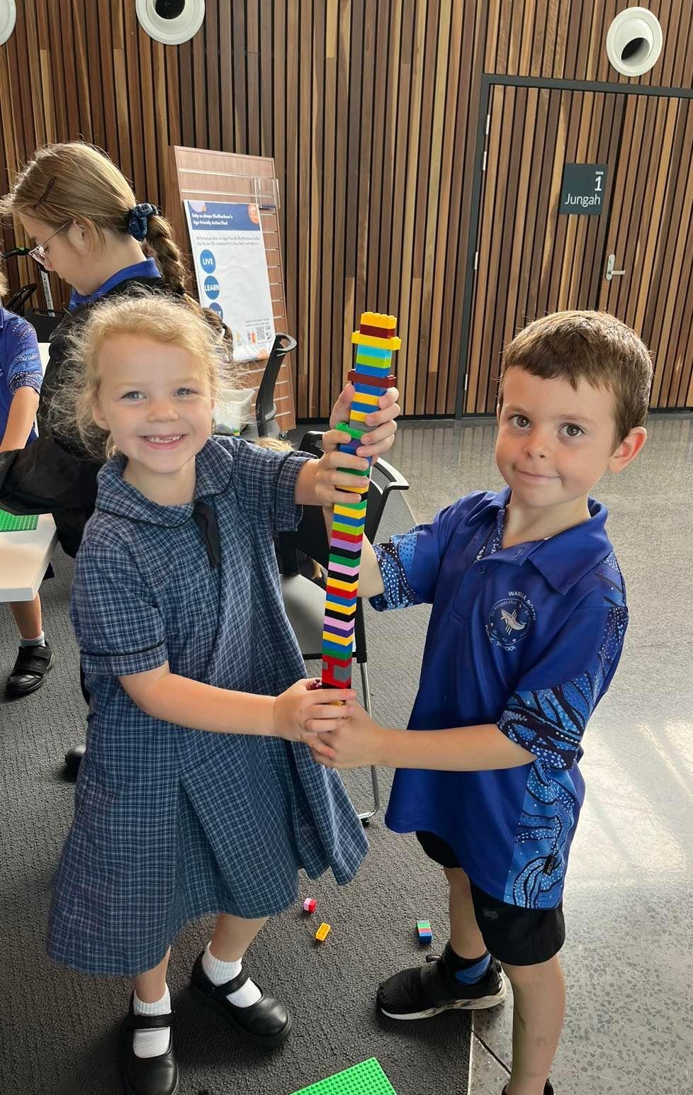
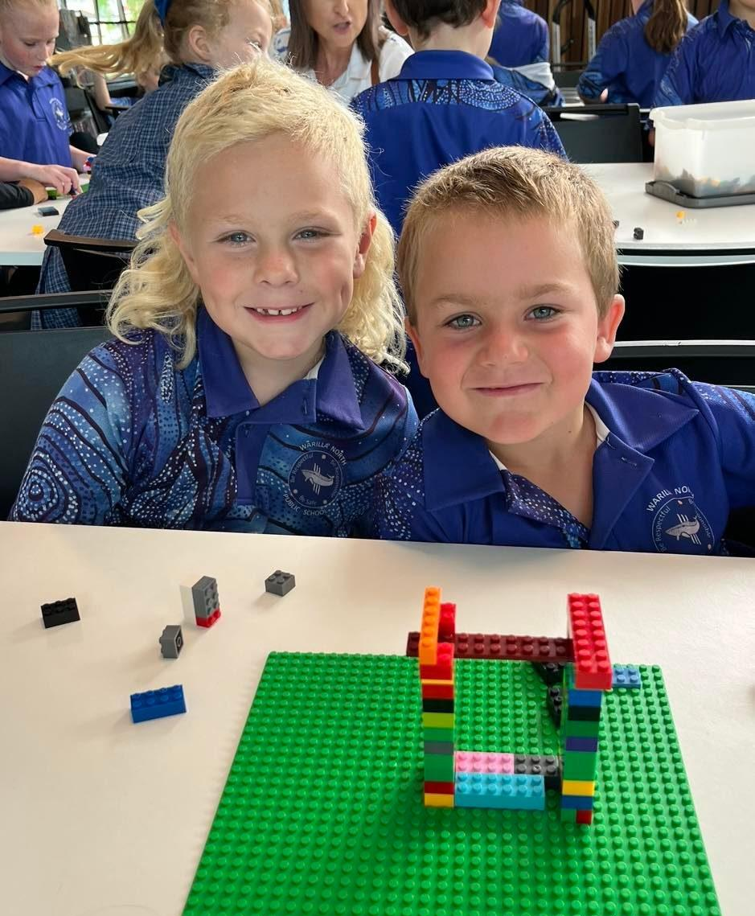
Gurunuba
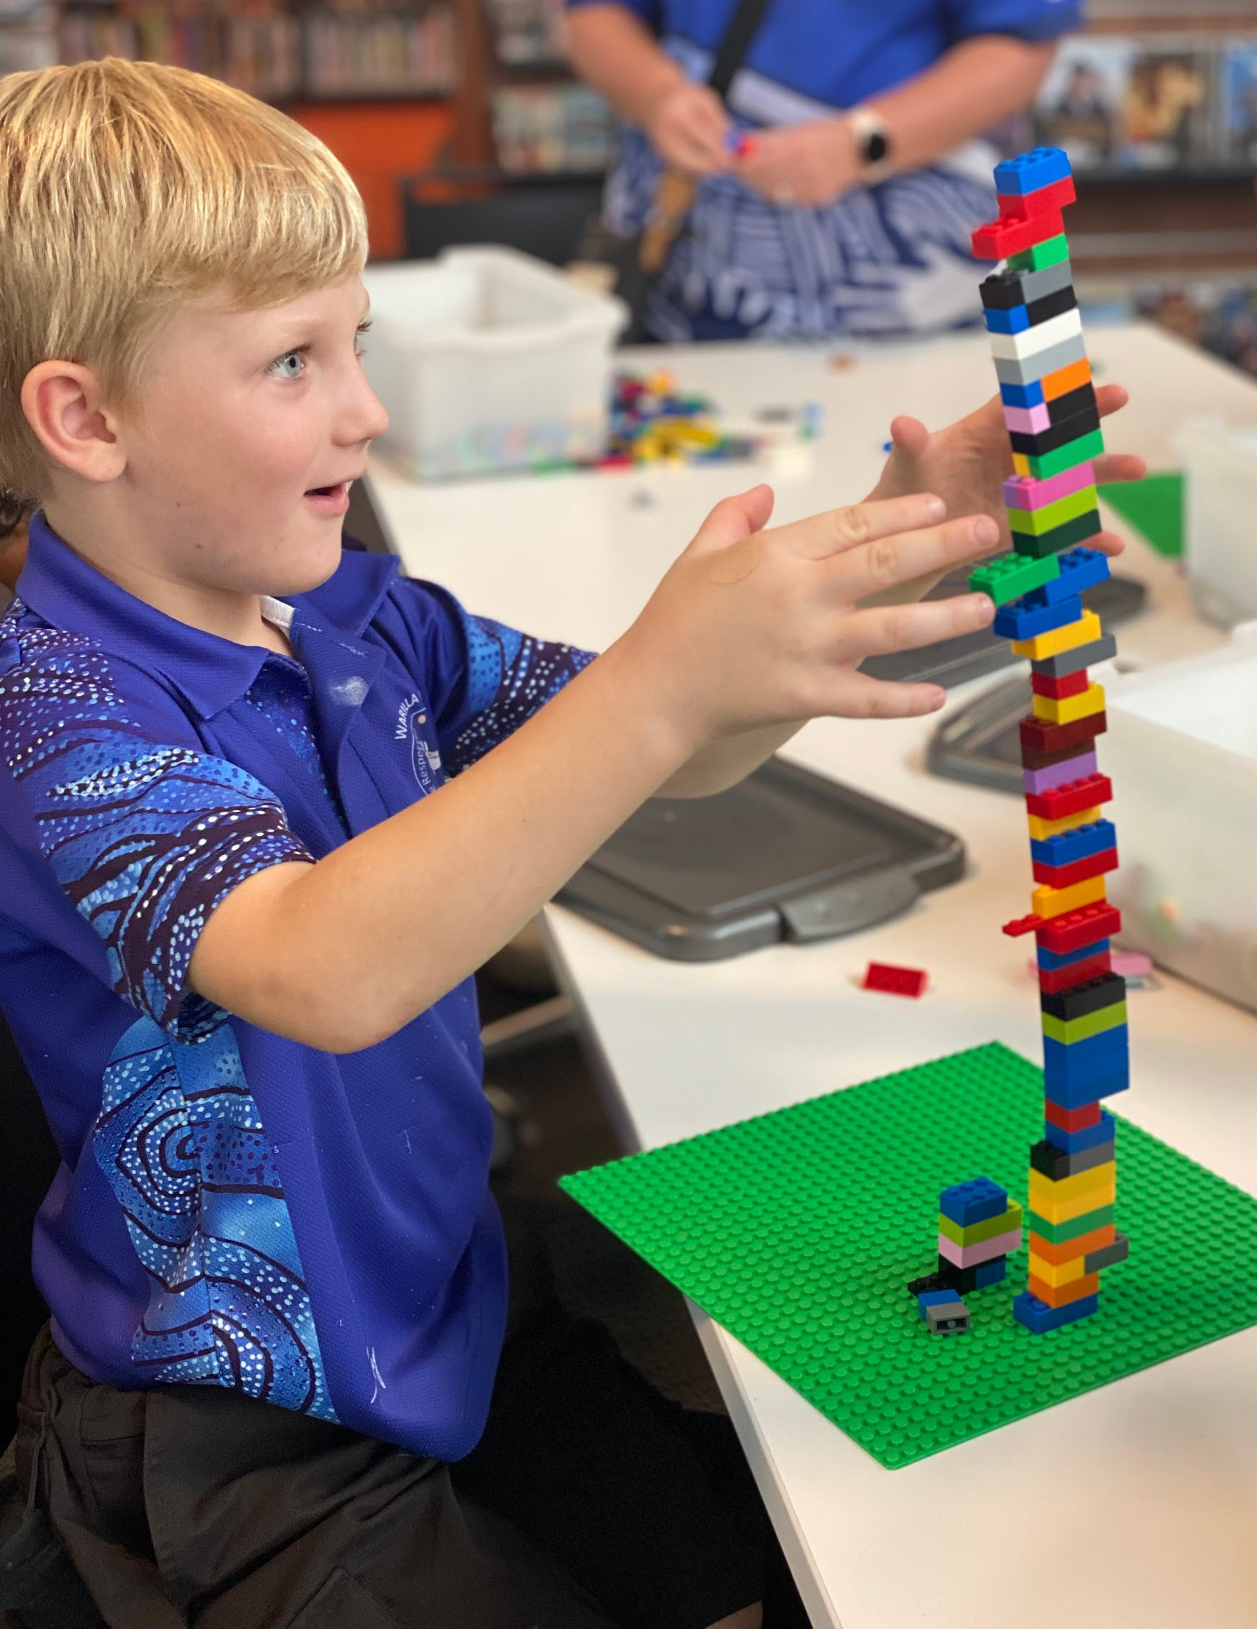
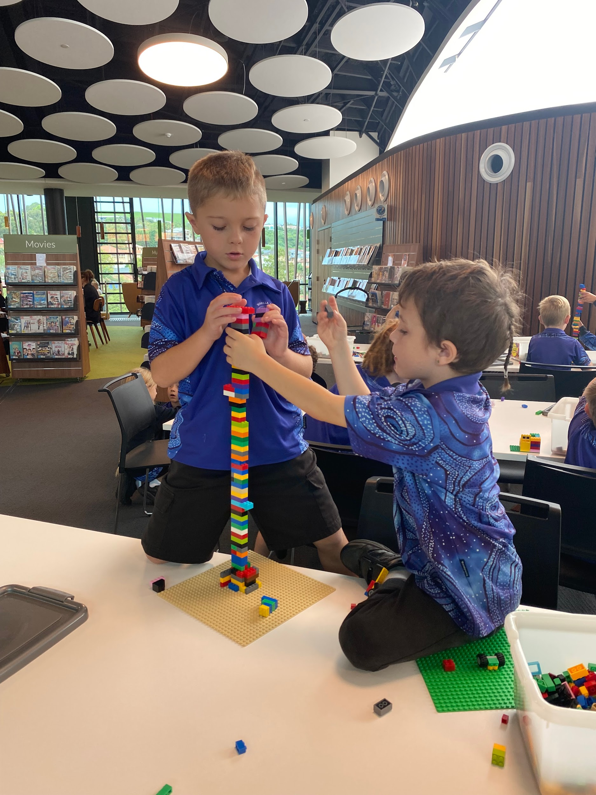
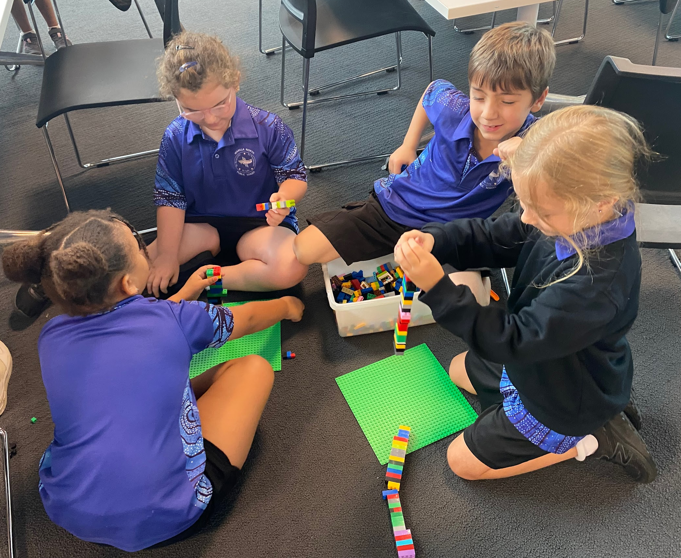
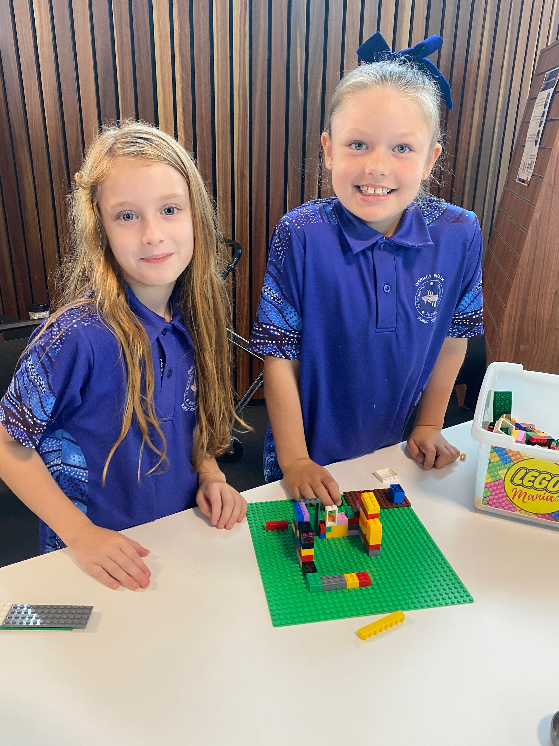
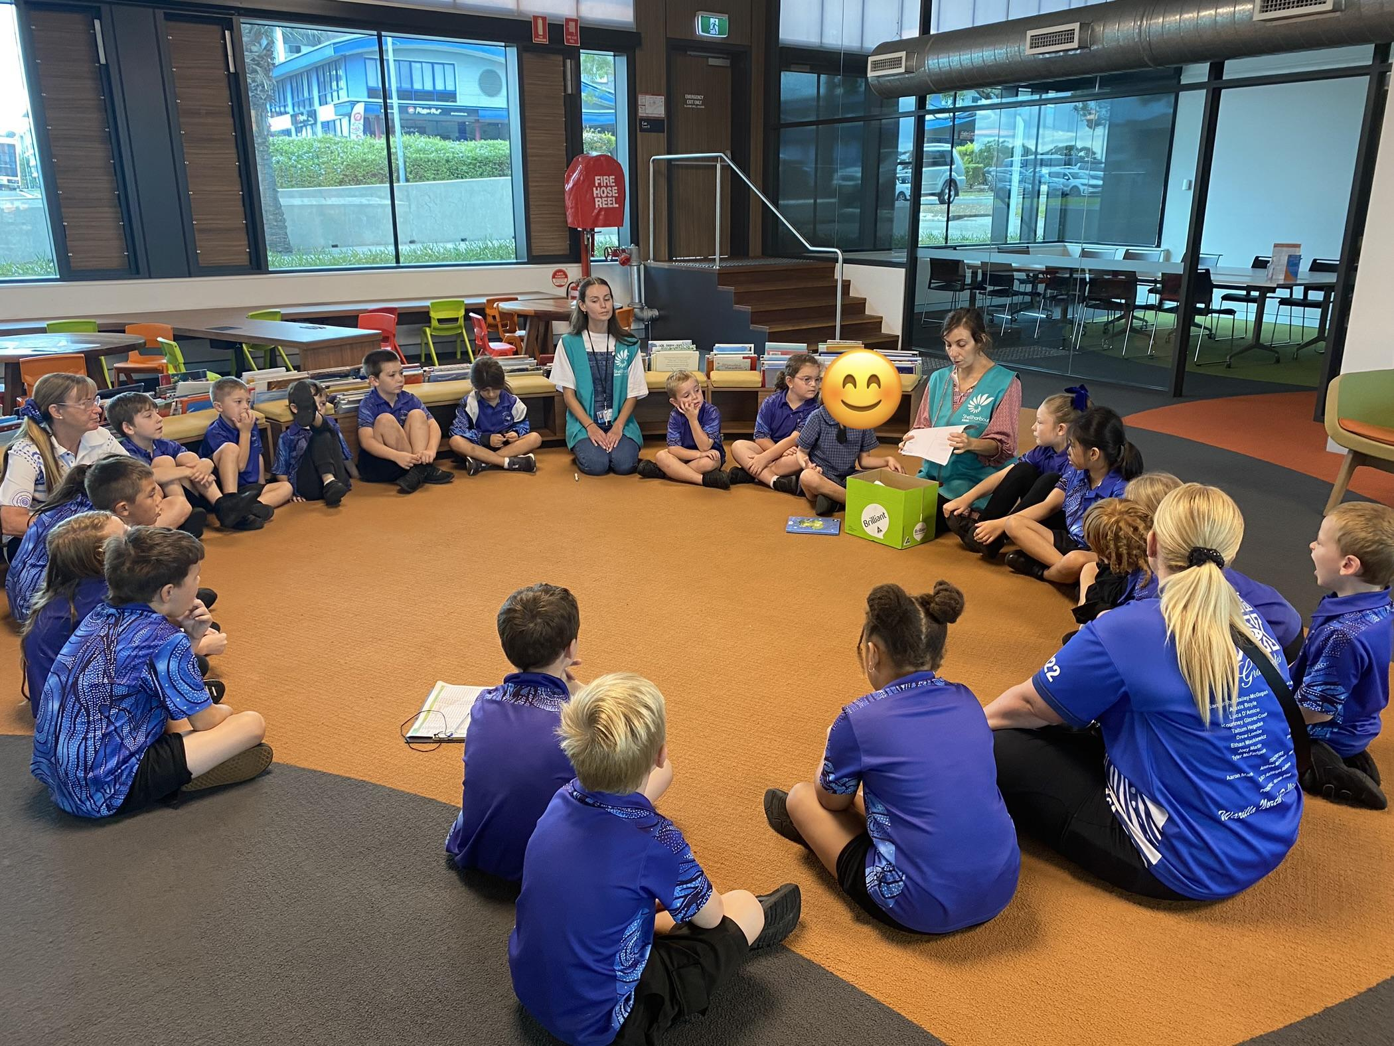
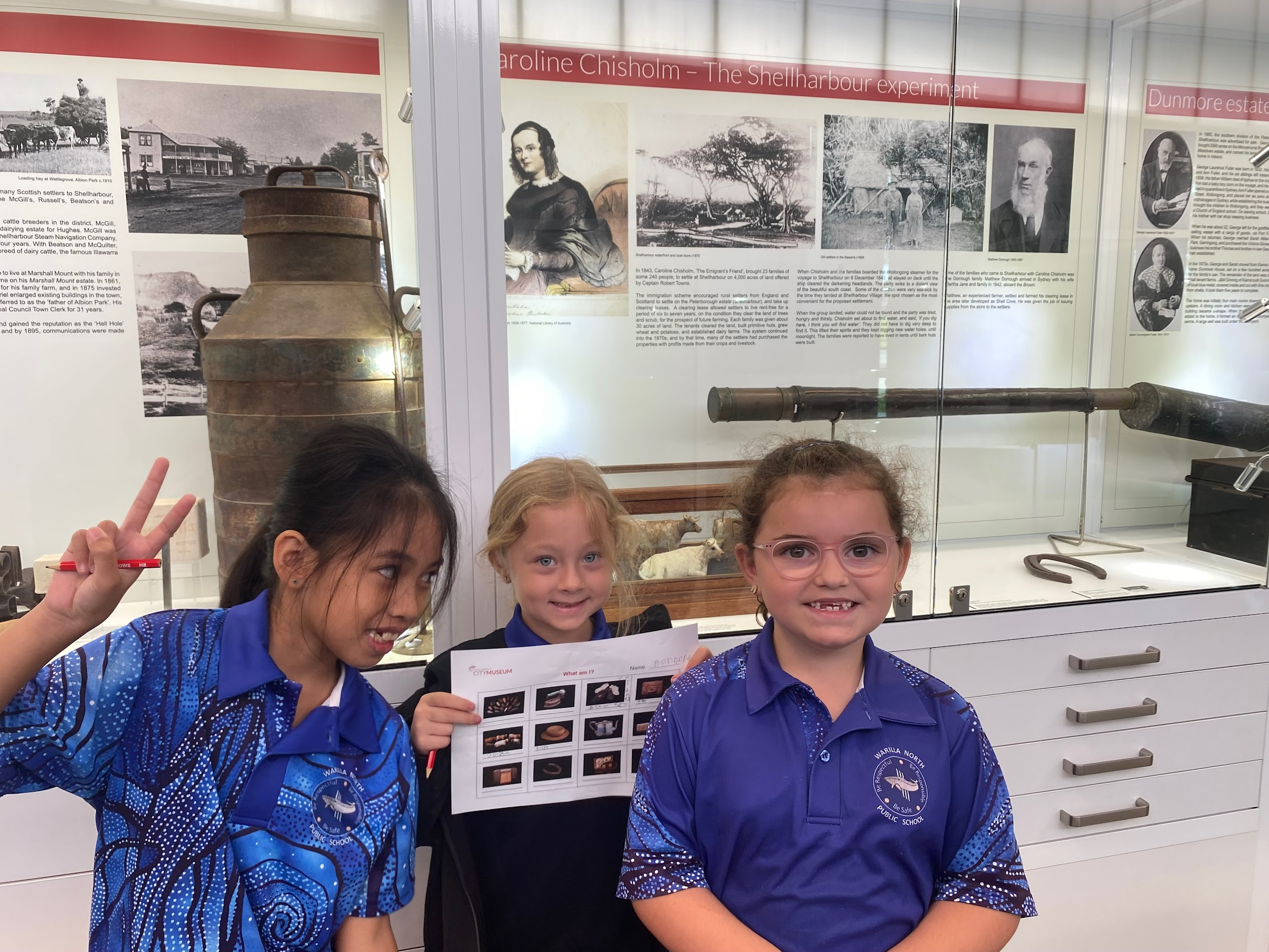
Attendance Information and Updates
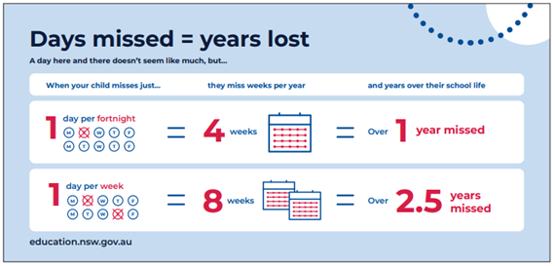

DID YOU KNOW?

Following an absence from school you must ensure that within 7 days you provide your child’s school with a verbal or written explanation for the absence. However, if the school has not received an explanation from you within 2 days, the school may contact you to discuss the absence.

